**Publish “SSIS Package” on the target server.**

1. Select package “Package.dtsx” in “Solution Explorer”.

2. Open menu “File => Save Copy of Package.dtsx As…”.

3. Add the destination server for publication in field “Server”.

4. Add a “Package path” with the package name “/MyFirstParameterSSISPackage”, click “OK” button.

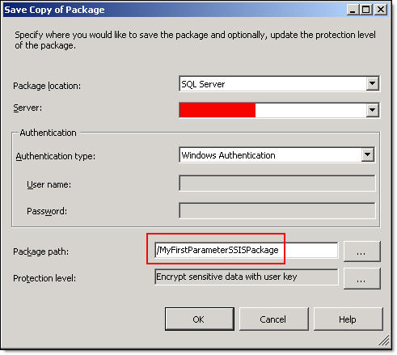

5. Verify that the package is successfully published in your destination “Integration Services” folder in “SQL Server”.

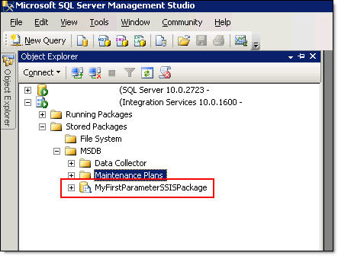

**Create the new “SQL Server” scheduled task to run your package and pass parameters**

1. Create a new job in your “SQL Server” named “JOB-MyFirstParameterSSISPackage”.

2. Add a new “New Job Step” named “STEP-MyFirstParameterSSISPackage”.

3. Select option “SQL Server Integration Services Package” in field “Type”.

4. In “General” tab configure “Package source”, “Server” and set value “\MyFirstParameterSSISPackage” in “Package” field.